NHS starts 'stem cell factory' for diabetes

20 October 2015

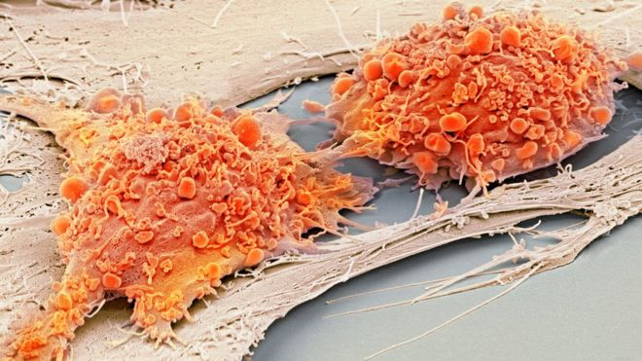
The NHS is setting up a stem cell factory in Liverpool to treat people with diabetes.
NHS Blood and Transplant wants to make and give the experimental therapy to patients at high risk of developing diabetes-related kidney problems.
It is hoped the injections will slow down or stop tissue damage, removing the need for dialysis or transplants.
Diabetes is the most common cause of end stage kidney disease, which kills around 40,000 people a year in the UK.
The 48 patients taking part in the study will be treated at University Hospitals Birmingham NHS Foundation Trust and Belfast Health and Social Care Trust or at another trial site in Italy.
The injection of cells they will receive are called stromal cells and they are grown from donated human bone marrow.
These immature cells can grow and change into a variety of tissue - bone, cartilage and fat. But it is their ability to release proteins that reduce inflammation in the kidney which interests the researchers.
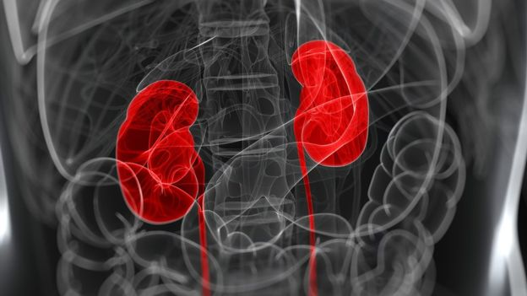IEPRO/SCIENCE PHOTO LIBRARY
In animal studies, stromal cell injections have provided measurable improvements in kidney function and it is hoped they will do the same in people.
Only some of the patients in the study will get the real jab (at different doses). The others will get a dummy injection. This will let the investigators check whether the treatment really works and if it has any side effects.
Project leader Prof Timothy O'Brien, from the National University of Ireland, Galway, said: "Diabetic kidney disease is very common so any therapy that could slow the progression of this disease would have a significant impact."
About three in four people with diabetes will develop kidney disease. It is caused by damage to the small blood vessels that supply the kidneys. But it can be prevented or delayed by keeping blood sugar and blood pressure levels under tight control.
Dr Eric Austin, head of Stem Cell Immunotherapy at NHS Blood and Transplant's site in Speke, Liverpool, said: "This is an exciting project for us to be involved with - especially as the treatment has the potential to lead to lifesaving outcomes for a major illness."
The research project, NEPHSTROM, is being funded by a 6m euro grant from the European Union Horizon 2020 programme.

